# Growth Locations Dropdown

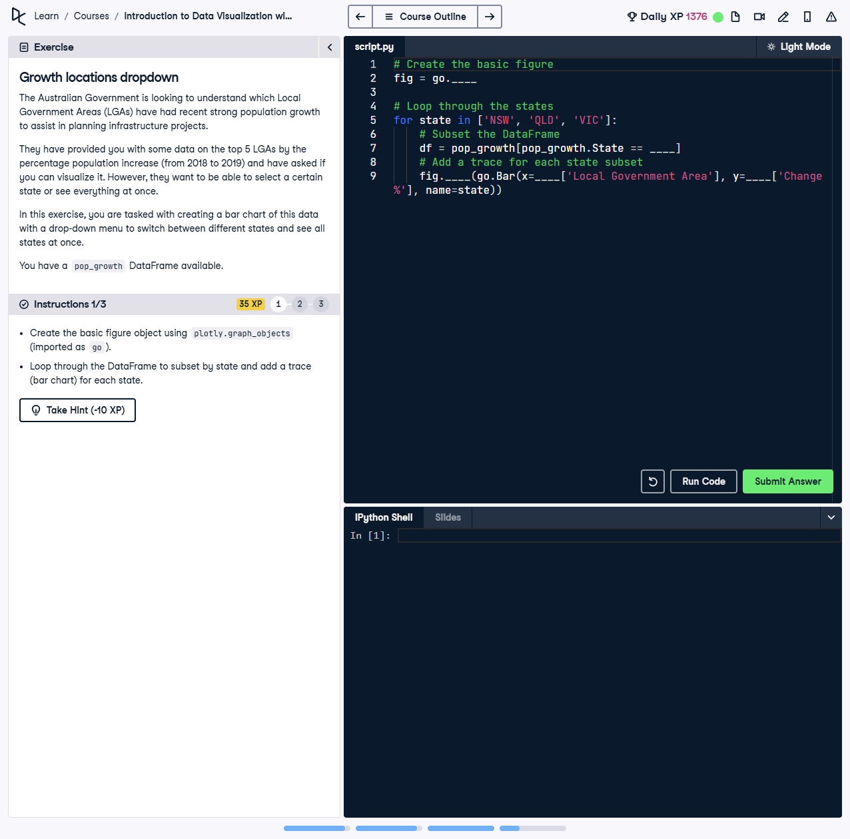

## Question

The Australian Government is looking to understand which Local Government Areas (LGAs) have had recent strong population growth to assist in planning infrastructure projects.  
  
They have provided you with some data on the top 5 LGAs by the percentage population increase (from 2018 to 2019) and have asked if you can visualize it. However, they want to be able to select a certain state or see everything at once.  
  
In this exercise, you are tasked with creating a bar chart of this data with a drop-down menu to switch between different states and see all states at once.  
  
You have a `pop_growth` DataFrame available and need to:  
1. Create the basic figure object using `plotly.graph_objects` (imported as `go`).  
2. Loop through the DataFrame to subset by state and add a trace (bar chart) for each state.

## Question Explanation

This task involves creating a bar chart for population growth data and incorporating a drop-down menu to filter data by state or view all states combined. The solution requires iterating through the DataFrame and dynamically updating the chart.

## Solution

Here is the solution to the task:  
  
```python  
import plotly.graph_objects as go  
import pandas as pd  
  
# Assume pop_growth DataFrame is already loaded with columns:  
# 'State', 'Local Government Area', 'Change %'  
  
# Create the basic figure  
fig = go.Figure()  
  
# Loop through the states  
states = ['NSW', 'QLD', 'VIC']  
for state in states:  
 # Subset the DataFrame  
 df = pop_growth[pop_growth.State == state]  
  
 # Add a trace for each state subset  
 fig.add_trace(go.Bar(  
 x=df['Local Government Area'],  
 y=df['Change %'],  
 name=state  
 ))  
  
# Add a dropdown menu to switch between states  
buttons = [  
 {  
 'label': 'All States',  
 'method': 'update',  
 'args': [{'visible': [True, True, True]}]  
 }  
]  
for i, state in enumerate(states):  
 visibility = [False] * len(states)  
 visibility[i] = True  
 buttons.append({  
 'label': state,  
 'method': 'update',  
 'args': [{'visible': visibility}]  
 })  
  
# Update the layout with the dropdown menu  
fig.update_layout(  
 updatemenus=[{  
 'buttons': buttons,  
 'direction': 'down',  
 'showactive': True  
 }]  
)  
  
# Show the plot  
fig.show()  
```

## Solution Explanation

1. The `pop_growth` DataFrame is iterated over to filter data for each state ('NSW', 'QLD', 'VIC').  
2. For each state, a bar chart trace is added to the figure, displaying the population growth percentage for its LGAs.  
3. A dropdown menu is created with options for 'All States' and individual states ('NSW', 'QLD', 'VIC').  
4. The visibility of each trace is controlled by the dropdown menu, allowing dynamic filtering of the chart.  
5. The layout is updated with the dropdown menu positioned correctly for user interactivity.